Ceramic Studio Tool Guide

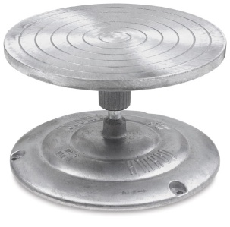 | Banding Wheel  A turntable used to assist in carving lines around objects and working with projects that are difficult to lift and turn.
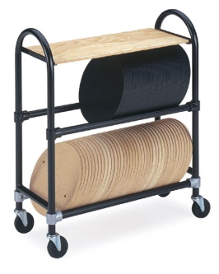 | Bats & Bat Mobile  Used to give stability to work while storing. Also used to throw clay on while on pottery wheel.
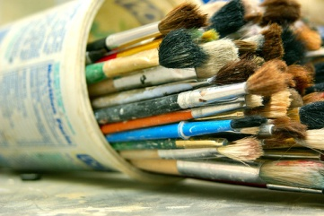 | Brushes  Can be used to smooth work out by using water on clay. Used primarily for the application of glaze.
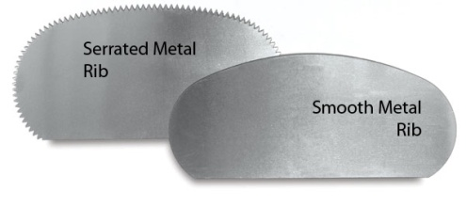 | Serrated Metal Rib  Used to score clay for slipping and scoring. Also can be used to add texture to clay.  Smooth Metal Rib  Used to smooth clay out, scrape clay up, and model clay.
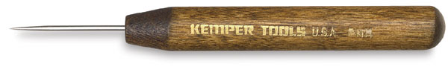 | Pin/Needle Tool  Used for tracing, designing, and poking holes in clay. Used to help remove air bubbles in clay by poking bubbles with tool.
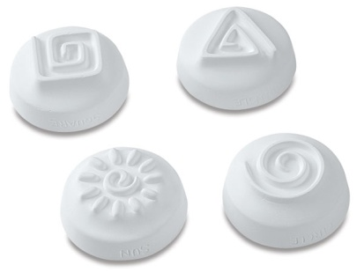 | Press Mold Stamps  Pushing these into clay will leave the design that is shown in the clay but reversed.
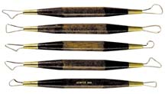 | Ribbon Tools  Used for carving designs, hallowing objects, or banding lines on objects.
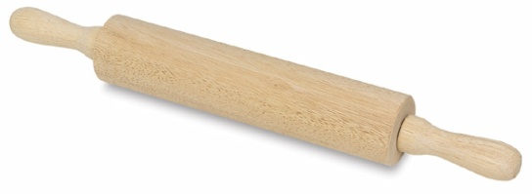 | Rolling Pin  Used to manually flatten clay.
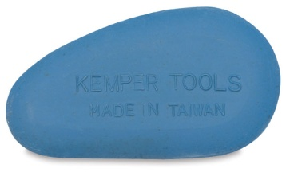 | Rubber Rib  Used to smooth and shape clay
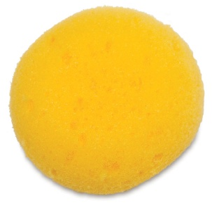 | Sponge  Can be used to smooth out clay with water and also helpful in shaping clay on the wheel.
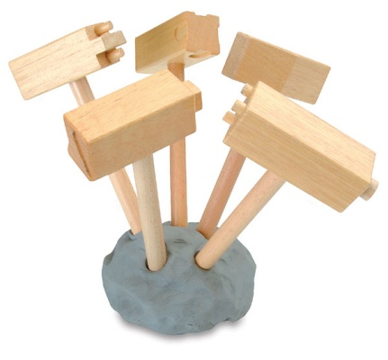 | Texture Hammers  Different designs on these mallets let you tap in shapes and designs into the clay.
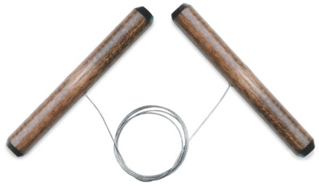 | Wire Clay Cutter  Used to cut clay from large blocks and remove clay that is stuck to surfaces.
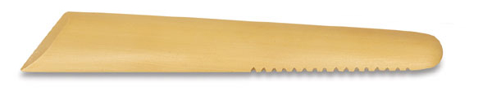 | Plastic Modeling Tool  Used for smearing, blending, and shaping clay during hand building.
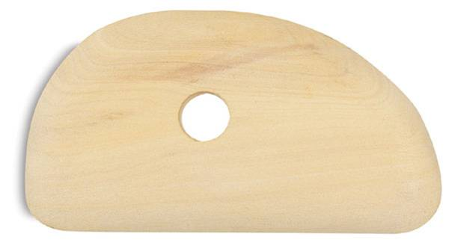 | Wooden Rib  Shape clay with this ridged tool. Great for moving clay around when hand building and working on the wheel.

